Question 7 [6 Points]
Write a shell script patterns.sh that reads a text file and:
• Writes words containing ONLY vowels into vowels.txt
• Writes words containing ONLY consonants into consonants.txt
• Writes words containing both vowels and consonants but starting with a consonant into mixed.txt, Case should be ignored while checking patterns.
-----
Script:
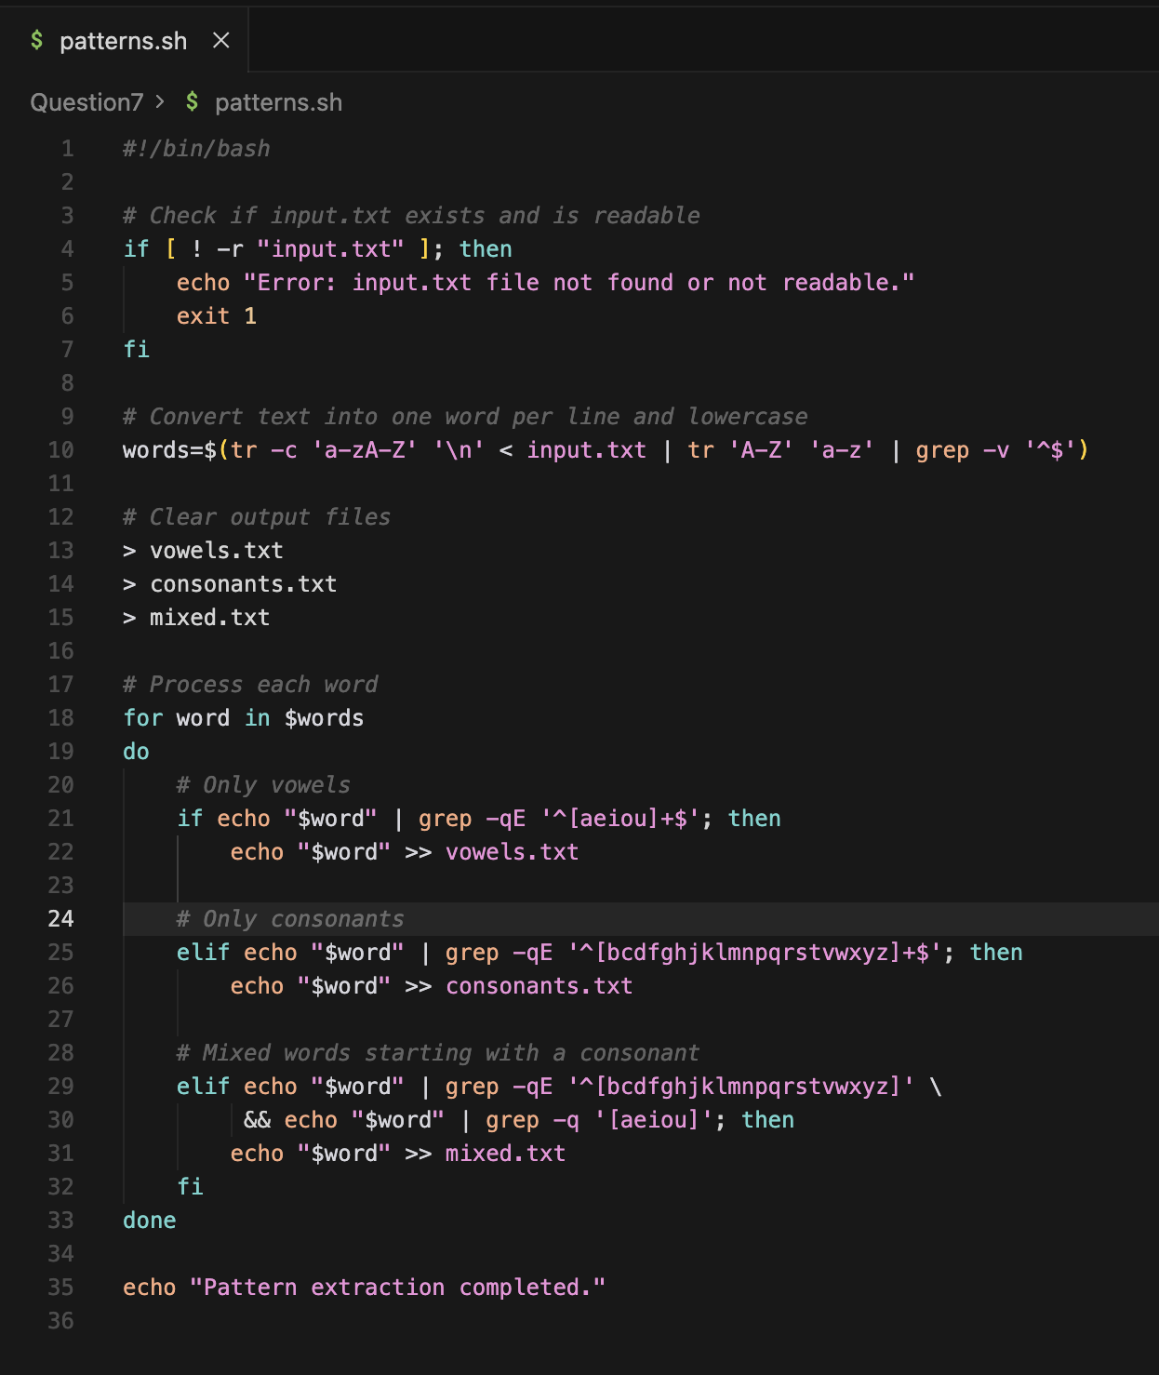
Explanation:
words=$(tr -c 'a-zA-Z' '\n' < input.txt | tr 'A-Z' 'a-z' | grep -v '^$')

tr -c 'a-zA-Z' '\n: replace non-letters with newline
if echo "$word" | grep -qE '^[aeiou]+$'; then
^[aeiou]+$ : only vowels
-q : quiet
-E : extended regex
In conclusion:
The Script classifies words using regular expressions to detect vowels and consonants, processes text case-insensitivity, and redirects results into separate files

Output:

